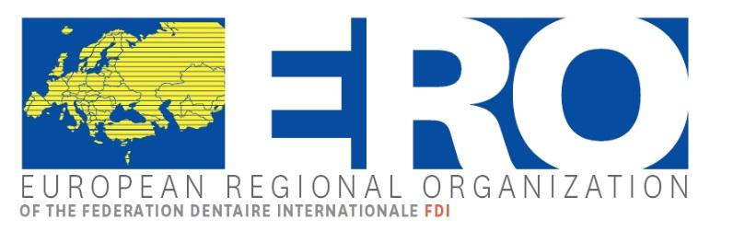 | 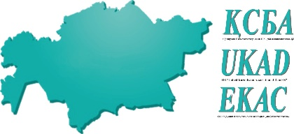 | 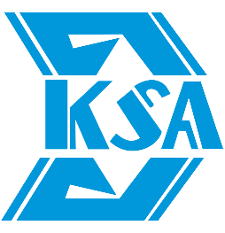

European Regional Organization
Plenary Session
2-3 May 2025, Almaty, Kazakhstan

REGISTRATION FORM

Please fill in one registration form per participant and send this form by fax or email before February 28th at the latest to:

NGO "Kazakhstan Stomatological Association"
Address: Kazakhstan, Astana city, Barayev St,13
Email: ospanova61@mail.ru
baigulakov@gmail.com
Telephone: + 7 701 331 46 49 (Azamat Baigulakov)
+ 7 701 803 00 48 (Abay Kalymtay)

Association: ______________________________________________________________________

❒ Mrs/Ms ❒ Mr Title: ____________________________________________________________

Last name: ______________________________________________________________________

First name: _______________________________________________________________________

❒ Delegate ❒ Alternate ❒ Guest

Country: ________________________ Zip Code: _________ City: __________________________

Phone: ____________________________________ Fax: __________________________________

Mobile: ____________________________________ E-Mail: _______________________________

Accompanying Person ❒ Mrs/Ms ❒ Mr ______________________________________________

Accompanying Person ❒ Mrs/Ms ❒ Mr ______________________________________________

Recreational program

Please indicate number of persons -> | Number | € per person | Total
Thursday 1st May 2025

❒ Welcome Cocktail – 19:30-21:00 - Intercontinental Hotel |  | Complimentary* | 0.00
Friday, 2nd May 2025

❒ Lunch - 12:30-13:30 - Intercontinental Hotel |  | Complimentary* | 0.00
❒ Gala Dinner - 19:00 – House of Receptions |  | 100.00
Saturday, 3rd May 2025

❒ Lunch 12.30-14.00 at Saksaul Restaurant (min. 50 participants) |  | 30.00
❒ City Tour – 15.00 – 18.00 (min. 50 participants) |  | 45.00
❒ Vegetarian

❒ Food intolerances
Grand Total

*The Complimentary meals and the transport to the Gala Dinner venue are offered by the Kazakhstan Dental Associations and Intercontinental Hotel.

Post-Plenary Trip Programs – Please see separate Programs
For those interested in the trip to Tashkent, please contact the tour organizer at:
info@khanturan.com - +7 701 2043439

Method of Payment:
❒ Bank Transfer:
I agree to transfer the registration total amount of € ……….. to the following bank account:
Please note, that all bank transaction fees that might arise while transferring the amount, must be covered by you. If those fees are not covered by you, your payment will not be in full amount, and you will have to cover the rest on site. An invoice will be issued including all services.

Bank  Bank address | JSC “First Heartland Jusan Bank”  Sarayshyk street, 5/a, Astana
IBAN | KZ56998BTB0000605134 (EUR)
BIC/SWIFT | TSESKZKA
Details of payment | BIN : 010240006532
Account name | LLP “Kazakhstan Stomatological Association”  OO “Kazakhstanskaya stomatologicheskaya assotsiatsiya”

❒ Credit Card:
If you prefer to pay with credit card, your payment link will be sent by PCO after sending this registration form.

Request for Visa Letter
❒ Do you need an invitation letter for Visa?
Please provide us herewith with your passport details
Date
Signature

Please return this form before February 28th, 2025

