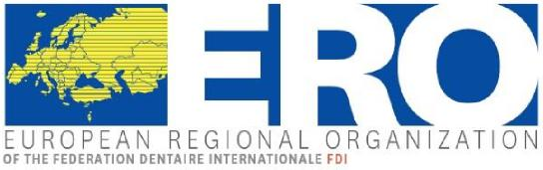
ERO-Plenary Session
29th/30th April, 2022, Bucharest, Romania
Accor Conference Center
Calea Victoriei nr. 37, Bucharest

Friday, 29.04.20122 14.00 h - 17.30 h
Saturday, 30.04.2022 08.30 h - 12.00 h

A G E N D A

Friday, 29th April 2022
14.00 A Welcome
A.1 ERO-President Michael Frank
A.2 Welcome of guests Michael Frank
A.3 Greetings of the president of the Paula Perlea
Romanian Dental Association

B Presentation by the President of the Paula Perlea
Romanian Dental Association
14.30 C Standard agenda of the business meeting
C.1 Roll call Taner Yücel
Establishment of the quorum
C.2 Approval of the agenda Michael Frank
C.3 Approval of the minutes of the online Taner Yücel
Plenary session 2021
C.4 Report of the Board

C.5 Report from EDSA President Ivana Ligusová
15.10 C.6 Finances Oliver Zeyer
6.1 Settlement of accounts 2021
6.2 Outstanding fees
6.3 Report of the auditor
6.4 Appointment of the auditor
6.5 Budget 2022

15.45 Coffeebreak

16.15 C.7 Presentation of the candidates
(ERO Board elections mandate 2022-2025)

C.8 Working groups
8.1 Ageing Population Henk Donker
8.2 Liberal Dental Practice in Europe Ernst-Jürgen Otterbach
8.3 Relations between dental Mare Saag
practitioners and universities
8.4 Integration Vladimer Margvelashvili
8.5 Continuing medical education in Hande Sar Sancakli
Dentistry
8.6 Dental Team Doniphan Hammer
8.7 Digitalization in dentistry – Roman Smucler
E-Health – Artificial Intelligence
8.8 Approval of the reports of the Michael Frank
Working groups

17.30 End of the 1st day
****************************

Saturday, 30th April 2022

08.30 C.9 Member countries Taner Yücel
Admission/Resignation of new members
National reports and discussion

09.45 Coffee break

10.15 C. 10 Elections

C. 11 FDI matters - report Nikolai Sharkov

C.12 Next meetings Michael Frank
Plenary session 2022 (Autumn)
Plenary session 2023 (Spring)

C.13 Miscellaneous Michael Frank

C.14 Handing over of the presidency

12.30 D Close of the meeting Michael Frank
Adjournment

President: Dr. Michael Frank (Germany) • President-Elect: Dr. Simona Dianišková (Slovakia) •
Secretary General: Prof. Taner Yücel (Turkey) • Treasurer: Dr. Oliver Zeyer (Switzerland) • Councilor: Edoardo Cavallé (Italy)
ERO-Secretariat, Monika Lang, Muenzgraben 2/P.O. Box, CH-3001 Bern, Tel. ++41 31 313 31 61/Fax ++41 313 31 40
mail: ero-sekretariat@sso.ch

Bank account: CREDIT SUISSE AG, 3001 Bern, Switzerland - Account No. 1872503-32, IBAN CH14 0483 5187 2503 3200 0, BIC CRESCHZZ80A
in the name of European Regional Organisation of FDI, 1216 Cointrin, Switzerland

