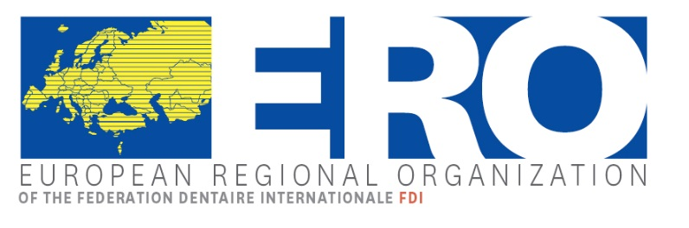 | Romanian Society of Stomatology

European Regional Organization
Plenary Session
28/29 – 30 April 2022, BUCHAREST, ROMANIA

REGISTRATION FORM

Please fill in one registration form per participant and send this form by fax or email before February 28th at the latest to:

Romanian Society of Stomatology Phone: +40 722 625110
Str. Ionel Perlea nr. 10 Fax: +40 21 346 8888
RO - 010209 Bucharest e-Mail: srspres@gmail.com

Association: ______________________________________________________________________

Mrs/Ms Mr Title: ____________________________________________________________

Last name: ______________________________________________________________________

First name: _______________________________________________________________________

Delegate Alternate Guest

Country: ________________________ Zip Code: _________ City: __________________________

Phone: ____________________________________ Fax: __________________________________

Mobile: ____________________________________ E-Mail: _______________________________

Accompanying Person Mrs/Ms Mr ______________________________________________

Accompanying Person Mrs/Ms Mr ______________________________________________

Room Type: Single Twin Double Hotel: Grand Continental 5* Novotel 4*

Accommodation:

Hotel booking
Hotel booking should be done as soon as possible in order to guarantee the availability of rooms by each participant (or on behalf of each participant) directly to the Romanian Society of Stomatology, email srspres@gmail.com,

Please indicate the name of the hotel (5* Hotel Grand Continental, or 4* Hotel Novotel) and the type of the room (single, twin, double).

Hotels / Room types:
 | Number of nights | € | Total
Grand Hotel Continental, Single Room, Breakfast included |  | 95 €
Grand Hotel Continental, Double Room, Breakfast included |  | 105 €
Grand Hotel Continental, Twin Room, Breakfast included |  | 105 €
Hotel Novotel, Single Room, Breakfast included |  | 70 €
Hotel Novotel, Twin Room, Breakfast included |  | 80 €
Hotel Novotel, Double Room, Breakfast included |  | 80 €
Grand Total

Recreational program
 | Number | € | Total
Thursday 28th, April 2022

Two Castles Tour English – 07:30-17:30 |  | 90 €
Welcome Cocktail – 19:00-21:00 |  | Complimentary
Friday, 29th April 2022

Lunch - 12:30-13:30 Restaurant Accor for participant |  | Complimentary
Lunch - 12:30-13:30 Restaurant Accor for accompanying person |  | 25 €
Two Castles Tour English – 07:30-17:30 – for accompanying person |  | 90 €
Gala Dinner - 19:00 – Grand Ballroom, for participant |  | 75 €
Gala Dinner - 19:00 – Grand Ballroom, for accompanying person |  | 75 €
Saturday, 30th April 2022

Lunch - 12:30-13:30 Restaurant Accor for participant |  | 25 €
Lunch - 12:30-13:30 Restaurant Accor, for accompanying. Person |  | 25 €
The Bucharest city tour, half day, in the afternoon, for participant |  | 35 €
The Bucharest city tour, half day, in the afternoon, for accompanying person |  | 35 €
Grand Total

*The prices for the tours apply for groups of a minimum of 30 persons

*The Complimentary meals are offered by the Romanian Society of Stomatology

Method of Payment:

Bank Transfer:
I agree to transfer the registration total amount of € (with costs of hotel accommodation) to the following bank account:

Please note, that all bank transaction fees that might arise while transferring the amount, have to be covered by you. If those fees are not covered by you, your payment will not be in full amount and you will have to cover the rest on site. An invoice will be issued including all services.

Bank  Bank address | BANCA COMERCIALA ROMANA S.A.  Calea Plevnei nr. 159, cod postal 060013, Bucharest, Romania
IBAN | RO12 RNCB 0082 0441 7821 0001
BIC | RNCB RO BU
Details of payment | ERO Plenary Session Bucharest 2022
Account name | SOCIETATEA ROMANA DE STOMATOLOGIE

Credit Card:
Payment with credit card will be made on site, directly at the hotels, or to the tour operator.

Request for Visa Letter
Do you need an invitation letter for Visa?

Please provide us herewith with your passport details
Date
Signature

Please return this form before February 28th, 2022

