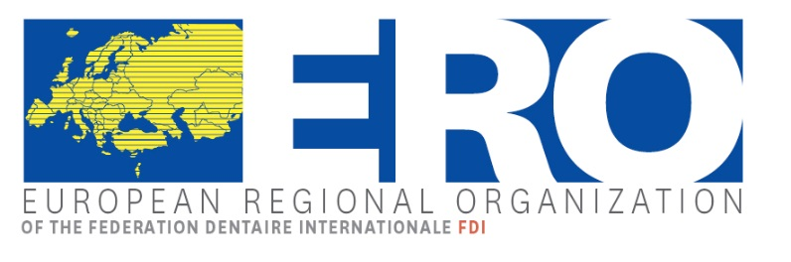

European Regional Organization
Plenary Session
13 – 14 April 2018, SALZBURG, AUSTRIA

REGISTRATION FORM

Please fill in one registration form per participant and send this form by fax or email before February 28th at the latest to:

Österreichische Zahnärztekammer Phone: +43 664 4310959
Kohlmarkt 11/6 Fax: +43 662 9010 2309
A-1010 Wien e-Mail: mayer@kinderzahnmedizin.at

Association: ______________________________________________________________________

Mrs/Ms Mr Title: ______________________________________________

Last name: ______________________________________________________________________

First name: _______________________________________________________________________

Delegate Alternate Guest

Country: ________________________ Zip Code: _________ City: __________________________

Phone: ____________________________________ Fax: __________________________________

Mobile: ____________________________________ E-Mail: _______________________________

Accompanying Person Mrs/Ms Mr ______________________________________________

Accompanying Person Mrs/Ms Mr ______________________________________________

Accommodation and meeting location

SALZBURG CONGRESS
Auerspergstr. 6
5020 SALZBURG – Austria
Tel: +43/(0)662 88987-0 Fax: +43/(0)662 88987 210
Email: servus@salzburgcongress.at Web: www.salzburgcongress.at

Hotel booking
Hotel booking (please use the special hotel reservation form) should be done as soon as possible in order to guarantee the availability of rooms (but before 13 March 2018 at the latest) by each participant (or on behalf of each participant) directly to Tourismus Salzburg GmbH.

Recreational program
 | Number | € | Total
Thursday 12th, April 2018

Welcome Cocktail – 19:00-21:00 Steinterrasse |  | free
Friday, 13th April 2018

Lunch - 12:30-13:30 Restaurant Mirabell Sheraton Grand for participant |  | 30 €
Lunch - 12:30-13:30 Restaurant Mirabell, for accomp. person |  | 30 €
Walk through the city of Salzburg English guide - 14:00-17:00 – approx. 3 hours , for accompanying person |  | 30 €
Gala Dinner - 19:00 – Stieglkeller, for participant |  | 80 €
Gala Dinner - 19:00 – Stieglkeller, for accompanying person |  | 80 €
Saturday, 14th April 2018

Lunch - 12:30-13:30 Restaurant Mirabell Sheraton Grand for participant |  | 30 €
Lunch - 12:30-13:30 Restaurant Mirabell, for accomp. person |  | 30 €
Visit of Salzkammergut  14:00-21:00 approx. , for participant |  | 70 €
Visit of Salzkammergut  14:00-21:00 approx. , for accompanying person |  | 70 €
Grand Total

The prices for the tours apply for groups of a minimum of 30 persons

- Cancellations less than 48 hours before the event will be charged to the provided credit card.

Method of Payment

Bank Transfer:
I agree to transfer the registration total amount of € (with costs of hotel accommodation) to the following bank account:

Please note, that all bank transaction fees that might arise while transferring the amount, have to be covered by you. If those fees are not covered by you, your payment will not be in full amount and you will have to cover the rest on site.

Bank | Österreichische Ärzte- und Apothekerbank AG, 1010 Wien, Schottengasse 10
IBAN | AT34 1813 0500 0021 0002
BIC | BWFBATW1
Details of payment
Account name | Österreichische Zahnärztekammer

Credit Card:
I hereby give permission to the organizer to charge the total amount to my credit card:

Name of Credit Card
(VISA, MasterCard)
Credit Card Holder
Card Number
Expiry Date (Month/Year)
CVD Code  Security Number (back of card) | (Visa, MasterCard: 3-digit number printed on the back of your card)

Request for Visa Letter
Do you need an invitation letter for Visa?

Please provide us herewith with your passport details
Date
Signature

Please return this form before February 28th, 2018

